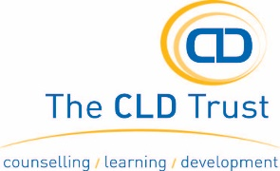
PERSON SPECIFICATION
Post Title: COUNSELLOR
TRAINING AND EXPERTISE | ESSENTIAL | DESIRABLE
Relevant nationally recognised qualification to Diploma or above, or equivalent (eg counselling, art therapy, psychotherapy)
At least 2 years post-qualifying clinical experience or significant related experience.
BACP accreditation, UKCP registration, BPS etc or eligible for same.
Significant experience in line with National Safeguarding requirements.
EXPERIENCE
Assessment for therapy including risk assessment.
Use of clinical supervision appropriately.
Providing therapy to a diverse client group.
Working with children and young people in a therapeutic setting.
SKILLS
A non-judgemental person-centred holistic approach to clients.
Able to think clearly under pressure and to tolerate confusion.
A calm and thoughtful approach to issue of clinical risk.
Able to recognise and monitor own responses and not let then impinge on clients.
Strong written and verbal communication skills including the ability to contribute to clinical discussion and planning.
Administration, record keeping and IT skills.
Fluent in languages other than English
BEHAVIORAL AND OTHER JOB-RELATED CHARACTERISTICS
Commitment to a person-centred approach to services (which account for the impact of psycho-social/cultural issues).
Willingness and ability to meet monitoring and evaluation requirements.
Understanding of and commitment to equality, valuing diversity and anti-discriminatory practice.
Aware of duties and responsibilities within health and safety requirements.
Identification and assessment of children, young people and vulnerable adults at risk.

